What will we be learning?  Unit RO43 – The body’s response to physical activity | Why this? Why now?  This unit is a compulsory coursework unit for the Sport Science course. This unit is taught in Year 11 as it is uses data collected from unit RO42 from Year 10. | Key Words:  Musculo-skeletal system  Cardio-respirtory system  Synovial joints  Connective tissue  Concentric contraction  Eccentric contraction  Blood pressure  Vascular shunt mechanism  Aerobic and anaerobic respiration
What will we learn?
LO1 - Know the key components of the Musculo-skeletal and cardio-respiratory systems and their functions
LO2 – Understand the importance of the Musculo-skeletal and cardiorespiratory systems in health & fitness
LO3 – Be able to assess the short term effects of physical activity on the musculo-skeletal and cardio-respiratory systems
LO4 - Be able to assess the long term effects of physical activity on the musculo-skeletal and cardio-respiratory systems
What opportunities are there for wider study?
Sixth form studies
- Cam Tech Sport
- A level PE
Careers/degree courses
- Sports science
- Physiotherapy
- PE teacher
How will I be assessed?
- Set OCR assignments under teacher supervision
CAM NAT – SPORT SCIENCE
UNIT RO43

LO1 - KNOW THE KEY COMPONENTS OF THE MUSCULO-SKELETAL AND CARDIO-RESPIRATORY SYSTEMS AND THEIR FUNCTIONS  Key components  - Major bones & skeletal muscle groups  - Synovial joints  - Connective tissue  - Functions of the Musculo-skeletal system  - Heart  - Respiratory system  - Blood & Blood vessels  - Functions of the cardio-respiratory system  Roles  - Types of movement & functions of connective tissue  - Muscle contractions  - Heart rate & blood pressure  - Vascular shunt mechanism  - Breathing mechanism & internal respiration  - Aerobic and anaerobic respiration | 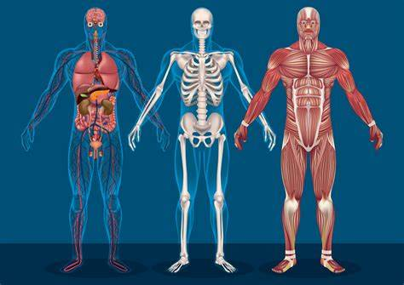
LO2 – UNDERSTAND THE IMPORTANCE OF THE MUSCULO-SKELETAL & CARDIORESPIRATORY SYSTEMS IN HEALTH & FITNESS

- Benefits of cardio-respiratory fitness in everyday life
- Benefits of muscular strength and flexibility
- Benefits of muscular endurance

LO3 – ASSESS THE SHORT TERM EFFECTS OF PHYSICAL ACTIVITY ON THE MUSCULO-SKELETAL & CARDIO-RESPIRATORY SYSTEMS  - Changes to systems  - Suitable activities to measure the short term effects  - Methods to measure the short term effects  - Recording the outcomes | 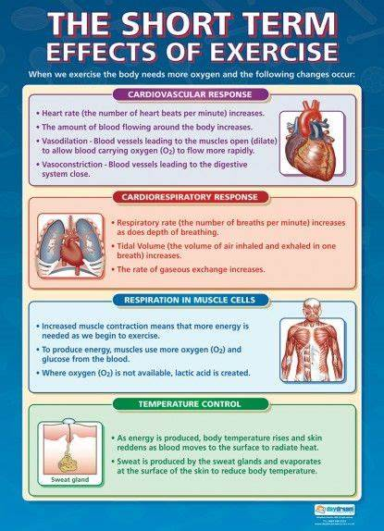
LO4 – ASSESS THE LONG TERM EFFECTS OF PHYSICAL ACTIVITY ON THE MUSCULO-SKELETAL & CARDIO-RESPIRATORY SYSTEMS  - Changes to systems  - Suitable activities to measure the long term effects  - Methods to measure the long term effects  - Recording the outcomes and subjective measures | 